DEPARTMENT OF COMPUTER SCIENCE AND ENGINEERING (CYBERSECURITY)
AMET UNIVERSITY, KANATHUR, CHENNAI

FINAL YEAR PROJECT — PHASE I / FIRST REVIEW
Attack Path Risk Engine
An Extension of Cartography for Automated Multi-Hop Attack Path Discovery and Risk-Based Prioritisation in Cloud Environments

1. Project Title
Attack Path Risk Engine

2. Team Details
S.no | Name | Register No. | Department
1 | Mohamed Abdul Baasid | ACS23004 | CSE (Cybersecurity)
2 | Rahsheetha | ACS23007 | CSE (Cybersecurity)
3 | Kithiyon | ACS23003 | CSE (Cybersecurity)

3. Problem Statement
Cartography builds a graph of cloud assets, identities, and permissions, but there is no automated way to (a) discover multi-hop attack paths from exposed entry points to sensitive targets, (b) score each path's relative risk, or (c) present findings without manual graph-query expertise. Most real-world cloud breaches arise not from one dramatic flaw but from a chain of ordinary, low-severity misconfigurations. This project addresses all three gaps.

4. Project Abstract
Cloud security incidents rarely come from a single flaw — they arise from chains of ordinary misconfigurations linking an exposed asset to sensitive data. Cartography, a CNCF open-source tool, already collects inventory from 30+ platforms into a Neo4j graph and names attack-path discovery as a goal, but today that discovery is entirely manual, requiring hand-written Cypher queries. This project builds the Attack Path Risk Engine on top of that graph: a depth-bounded traversal that automatically finds paths from exposed entry points to sensitive targets, a 0–100 risk-scoring model based on impact, hop count, privilege type gained, and any mitigating controls present; and a dashboard that reports ranked findings in plain, actionable language. Validation uses a seeded AWS sandbox, since no public benchmark of labelled cloud attack paths exists. Cartography's own source code stays unmodified; all new work is a separate, clearly attributed module under its Apache 2.0 licence. Phase I (~40% completion) delivers path-discovery and risk-scoring; Phase II (~60%) delivers the dashboard, integration, and final validation.

5. Objectives
- To study Cartography's architecture and data schema to identify where new functionality can be added without modifying its source code.
- To implement a path-discovery module that traverses the infrastructure graph from entry points to sensitive targets within a bounded depth.
- To design a quantitative risk-scoring model that ranks paths by severity, based on recognised cloud attack-path concepts.
- To build a web dashboard that presents ranked findings in plain language for a security reviewer.
- To validate the system against realistic misconfiguration scenarios in a controlled sandbox environment.

6. Domain Identification
Primary domain: Cybersecurity.
Sub-domains: Cloud Security, Cloud Infrastructure Security, and Attack Path Analysis — at the intersection of graph-based security analytics and cloud IAM.

7. Literature Survey
Eleven recent papers (IEEE, ACM, USENIX, Springer, Elsevier, Wiley, arXiv) were reviewed, focused on cloud IAM privilege escalation, attack-path generation, and attack-graph scalability — the areas most relevant to this project.
# | Paper | Venue / Year | Relevance
1 | Multi-target Risk Score Aggregation for Security Evaluation of Network Environments | IEEE CloudCom, 2024 | Pairwise path-based score aggregation across a network — directly informs the project's scoring-formula design.
2 | Fixing Privilege Escalations in Cloud Access Control with MaxSAT and Graph Neural Networks (IAMPERE) | IEEE/ACM ASE, 2023 | Automated detection and remediation of IAM privilege-escalation chains in cloud graphs.
3 | SkyEye: When Your Vision Reaches Beyond IAM Boundary Scope in AWS Cloud | arXiv, 2025 | Cross-principal AWS IAM enumeration — relevant to entry-point and privilege-boundary identification.
4 | CloudLens: Modeling and Detecting Cloud Security Vulnerabilities | arXiv, 2024 | Formal relational model of cloud IAM plus a planner that generates attacks to find vulnerabilities — closely related modelling approach.
5 | BRIDG-ICS: AI-Grounded Knowledge Graphs for Intelligent Threat Analytics in Industry 5.0 Cyber-Physical Systems | Springer (Cybersecurity, open access), 2026 | Neo4j Graph Data Science attack-path analysis using Yen's k-shortest-path and Dijkstra's algorithm — methodologically close to the project's path-discovery layer.
6 | Behind the Scenes of Attack Graphs: Vulnerable Network Generator for In-Depth Experimental Evaluation of Attack Graph Scalability | Computers & Security (Elsevier), 2025 | Addresses attack-graph scalability and synthetic dataset generation — informs the project's sandbox-validation approach.

8. Research Gap / Existing-System Gap
- Cartography and similar tools build a queryable graph of infrastructure, identities, and permissions, but none automate multi-hop attack-path search — a security engineer must hand-write a Cypher query for every question.
- IAM privilege-escalation detectors such as IAMPERE [2] and TAC [7] detect individual escalation types well but aren't built on a general-purpose, multi-platform infrastructure graph.
- Risk-scoring approaches such as [1] aggregate scores across a network but don't factor mitigating controls (e.g., MFA) into cloud IAM privilege-transition chains.
- No public, labelled benchmark of real-world cloud attack paths exists, a limitation shared across this field — addressed here through a documented sandbox validation methodology.

9. Proposed Solution
The Attack Path Risk Engine adds three layers on top of Cartography's graph, without modifying its source code: a path-discovery layer performing depth-bounded traversal from entry points to sensitive targets; a risk-scoring layer assigning each path a 0–100 score based on impact, path length, privilege-transition type, and mitigating controls; and a React dashboard reporting ranked findings in plain language. Together these convert Cartography's graph into a prioritised, automated list of an attacker's most viable routes.

10. Innovation / Novelty
The novelty lies in combining three properties, each present individually in prior work but not previously combined on a general-purpose, multi-platform infrastructure graph: (1) fully automated multi-hop path discovery rather than manual querying; (2) a documented, explainable risk-scoring formula that rewards real mitigating controls such as MFA rather than target sensitivity alone; and (3) implementation as a clean, separately attributed extension of Cartography, leaving its own code untouched.

11. Methodology

11.1 Path Discovery
A Python module queries Cartography's Neo4j graph, starting from nodes flagged as exposed or vulnerable, and runs a depth-bounded BFS with pruning to find paths reaching sensitive targets (data stores, admin roles, secrets managers).

11.2 Risk Scoring
Each path is scored as Risk Score = Impact(target) × Likelihood(path) × 10, where Likelihood(path) = DecayFactor(hops) × HopWeightProduct × MitigationMultiplier (derivation and worked examples in Section 11.3).

11.3 Worked Example
Formula and worked example
Risk Score = Impact(target) × Likelihood(path) × 10
Likelihood(path) = 0.85^(hops-1) × HopWeightProduct × MitigationMultiplier

Example — Public EC2 → AssumeRole (no MFA) → Production S3 Bucket (Impact = 9), 2 hops:
Likelihood = 0.85 × 0.9 × 1.0 = 0.765 → Risk Score = 9 × 0.765 × 10 = 68.9 (HIGH)

Example — Public EC2 → PolicyAttachment (MFA present) → Administrative Role (Impact = 8), 2 hops:
Likelihood = 0.85 × 0.7 × 0.5 = 0.2975 → Risk Score = 8 × 0.2975 × 10 = 23.8 (MEDIUM/LOW)

The second path targets a higher-privilege resource but scores lower because a real mitigating control (MFA) is present — demonstrating that the model rewards genuine security controls rather than ranking purely on target sensitivity.

11.4 Presentation
A React dashboard shows ranked paths as plain-language findings (e.g., "Public Web Server → Admin Role → Production S3 Bucket — Risk: HIGH"), with a node-by-node graph view of the selected path.

12. System Architecture
The system adds three new layers on top of Cartography's existing graph, as shown below.
Layer 3 — Presentation (New contribution — Technology: React)
React dashboard showing ranked attack paths in plain, actionable language.
e.g. "Public Web Server → Admin Role → Production Database — Risk: HIGH"
▲ data flows upward ▲
Layer 2 — Risk Scoring (New contribution — Technology: Python)
Scores every discovered path by path length, privilege gained per hop, and mitigations present.
Risk Score = Impact(target) × Likelihood(path) × 10 (see Section 11.3)
▲ data flows upward ▲
Layer 1 — Path Discovery (New contribution — Technology: Python)
Depth-bounded traversal from flagged entry points to defined sensitive targets.
Queries the graph Cartography already built — reads only, never modifies it.
▲ data flows upward ▲
Existing Base — Cartography (Untouched — Technology: Neo4j graph database, CNCF sandbox project, Apache 2.0)
Connects to 30+ platforms (AWS, GCP, Azure, Kubernetes, GitHub, Okta...) and loads
assets, identities, and permissions into a single graph, already flagging exposed nodes.
Figure 1. System architecture — Path Discovery, Risk Scoring, and Presentation layers built on Cartography's existing graph.

13. Hardware & Software Requirements
Component | Requirement
Base project | Cartography (Python, Apache 2.0 licence)
Graph database | Neo4j
Path discovery & scoring engine | Python 3.x
Dashboard | React
Cloud sandbox environment | AWS (free tier / student credits)
Development hardware | Standard development laptop; no GPU required
Version control | Git / GitHub

14. Dataset / Data Source
No public, labelled benchmark of real-world cloud attack paths exists (Section 7), so data is generated from a dedicated AWS sandbox account populated with representative misconfigurations (an exposed EC2 instance, an over-permissive IAM role, a production-like S3 bucket, and a secrets store). Cartography's existing, unmodified connectors pull this sandbox's inventory into the Neo4j graph the system operates on.

15. Expected Outcome
- Phase I (~40%): a working path-discovery module and validated risk-scoring engine, both on a live Cartography graph.
- Phase II (~60%): a usable web dashboard, full integration of all three layers, and validation against sandbox scenarios.
- A documented, justified risk-scoring model with worked validation scenarios.
- A final report and viva in which every design decision can be independently explained by each team member.

16. Project Timeline
The project spans the full academic year in two phases. Phase I (Aug–Dec 2026, ~40%) covers study, design, path discovery, and risk scoring. Phase II (Jan–May 2027, ~60%) covers the dashboard, integration, testing, and documentation.
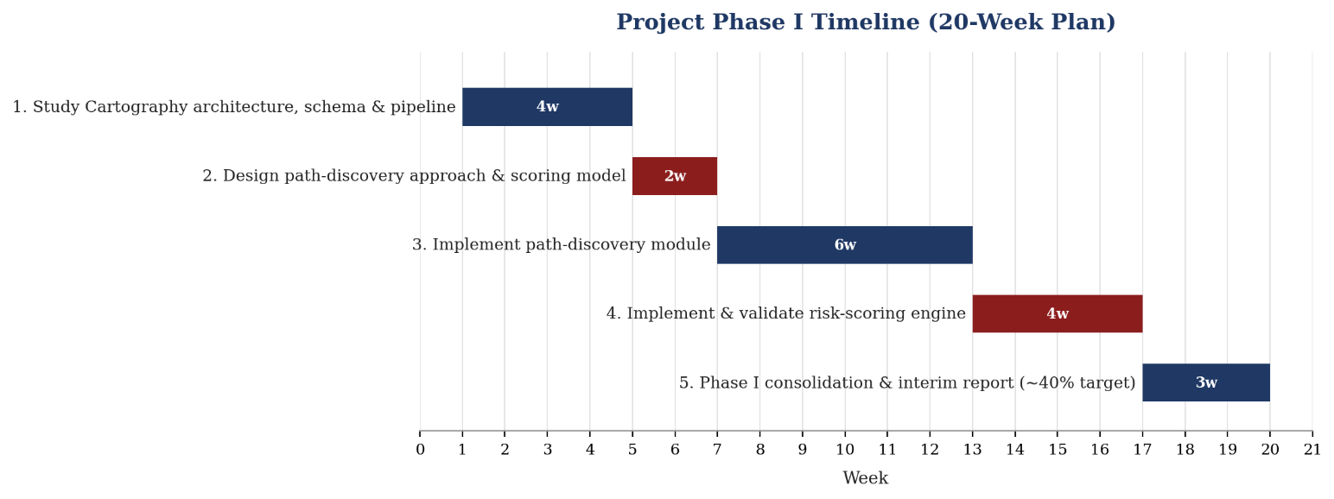

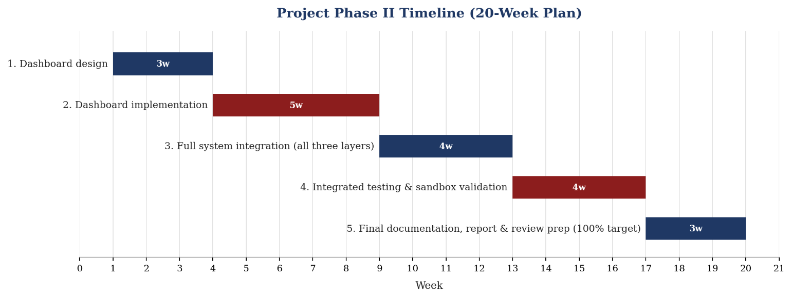
Figure 2. Full academic-year timeline — Phase I (Aug–Dec 2026) and Phase II (Jan–May 2027).

17. Work Distribution
Team Member | Primary Responsibility
Mohamed Abdul Baasid | Path discovery module; Cartography schema and intel-module study; graph query design
Rahsheetha | Risk-scoring model design, validation scenarios, and documentation of scoring justification
Kithiyon | Dashboard design and implementation; integration with backend outputs
All three members jointly study Cartography's core architecture before specialising, and co-author the design document, so each can explain the full system during evaluation.

18. References
[1] M. Lei, T. A. Madi, M. Nitschke, L. Zhao, and M. Pourzandi, "Multi-target Risk Score Aggregation for Security Evaluation of Network Environments," in Proc. 2024 IEEE Int. Conf. on Cloud Computing Technology and Science (CloudCom), 2024, pp. 71–78.
[2] Y. Hu, W. Wang, S. Khurshid, K. L. McMillan, and M. Tiwari, "Fixing Privilege Escalations in Cloud Access Control with MaxSAT and Graph Neural Networks," in Proc. 2023 38th IEEE/ACM Int. Conf. on Automated Software Engineering (ASE), 2023, doi: 10.1109/ASE56229.2023.00167.
[3] M. H. Nguyen, A. M. Ho, and B. S. To, "SkyEye: When Your Vision Reaches Beyond IAM Boundary Scope in AWS Cloud," arXiv:2507.21094, 2025.
[4] M. Kazdagli, M. Tiwari, and A. Kumar, "CloudLens: Modeling and Detecting Cloud Security Vulnerabilities," arXiv:2402.10985, 2024.
[5] P. Nandiya, A. Mohsin, A. Ibrahim, I. H. Sarker, and H. Janicke, "BRIDG-ICS: AI-Grounded Knowledge Graphs for Intelligent Threat Analytics in Industry 5.0 Cyber-Physical Systems," Cybersecurity (Springer, open access), 2026.
[6] A. Palma and S. Bonomi, "Behind the Scenes of Attack Graphs: Vulnerable Network Generator for In-Depth Experimental Evaluation of Attack Graph Scalability," Computers & Security, vol. 157, art. 104576, Oct. 2025.

